Week 6 Assignment

Jessica Gurung
Westcliff University , kings college
PRG 200
Professor
June 14, 2026

Question 1: Temperature Logger
In this program, the math module is used for analyzing the temperature data received at Kathmandu Weather Station. Here, get_average() and get_deviation() return average temperature and standard deviation respectively, using math.sqrt(). The summary of minimum, maximum, average, and deviation is calculated by get_summary(). In get_deviation(), mean is a local variable hence cannot be accessed globally.
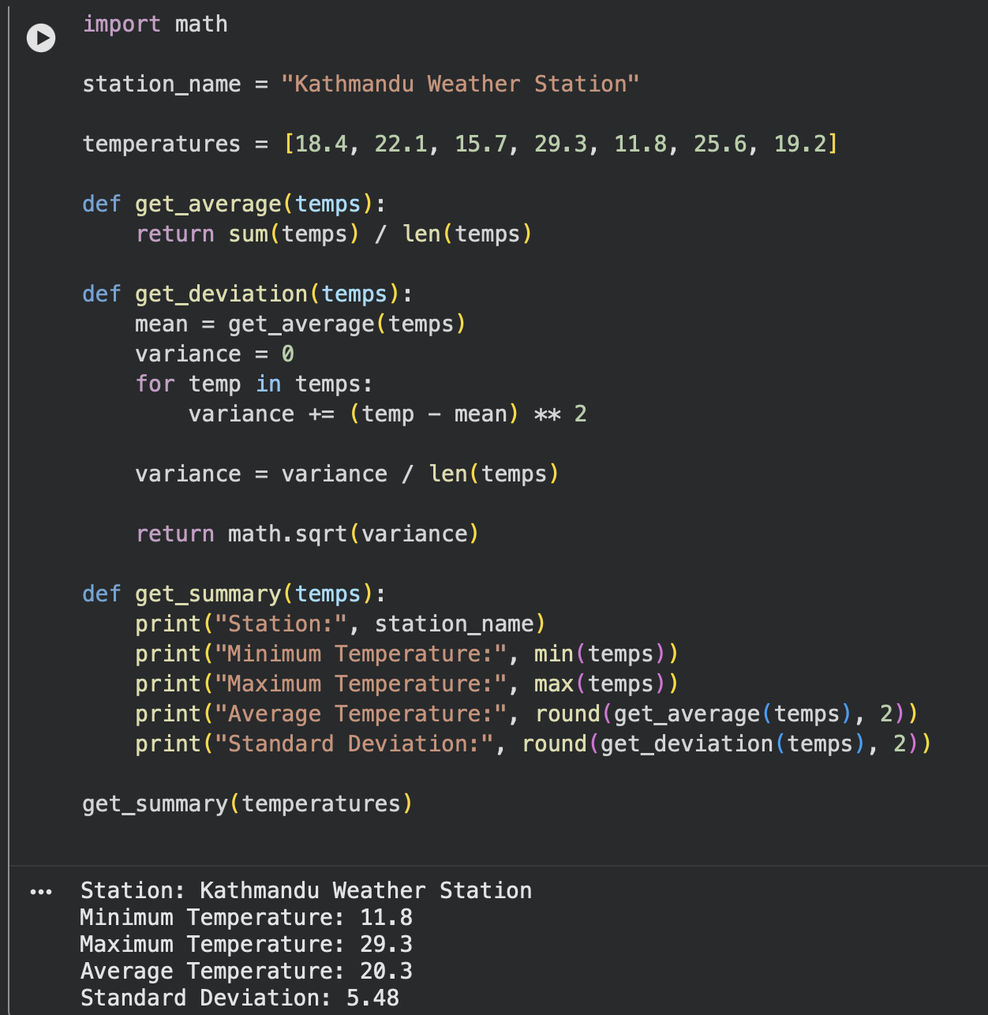

Question 2: Bill Splitter
The random module is used in this program to equally split the restaurant bill amongst the friends. Using split_bill(), we calculate the amount payable by each friend, whereas pick_lucky_person() chooses one person from all friends at random using random.choice(). This chosen person is to pay extra NPR 50 as lucky tax. lucky_total is the local variable used in final_summary().
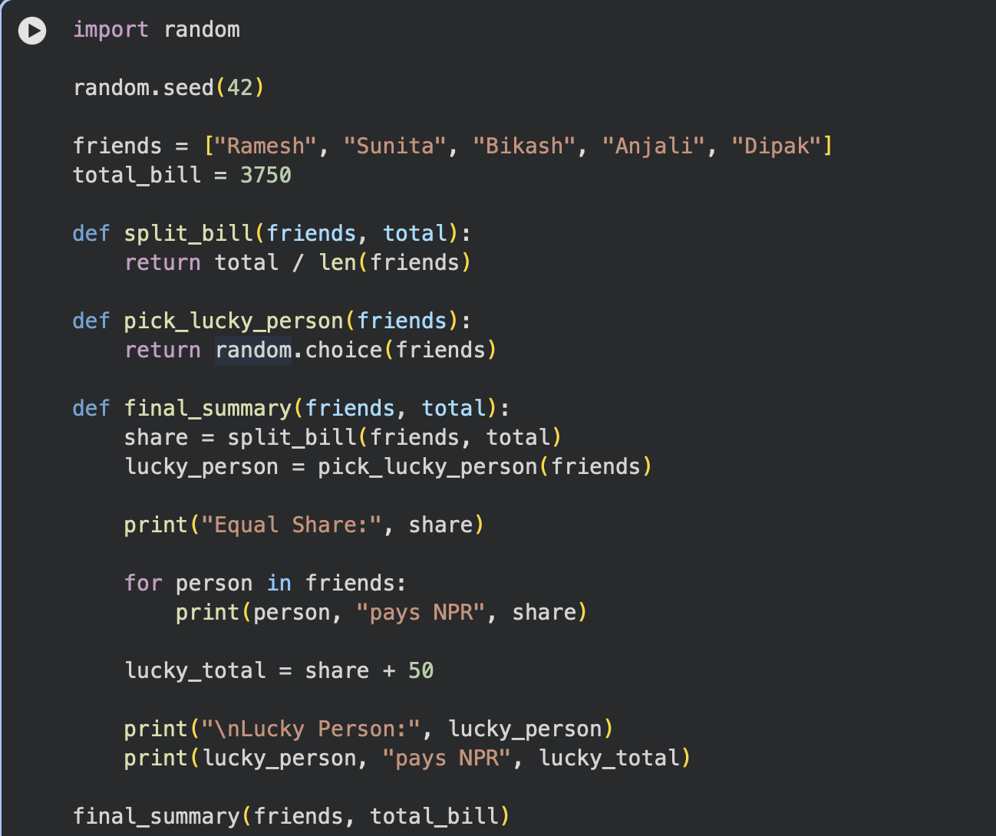
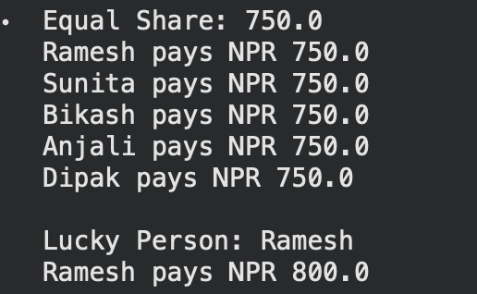
Question 3: Exam Scheduler
In this program, the datetime module is used to create a scheduler for exams. The parse_date() function takes string input and returns a date object. On the other hand, add_days() takes integer input and adds specified number of days to it using timedelta function. print_schedule() prints subject name and corresponding exam date. Here, college_name is the global variable used as header for the scheduler.
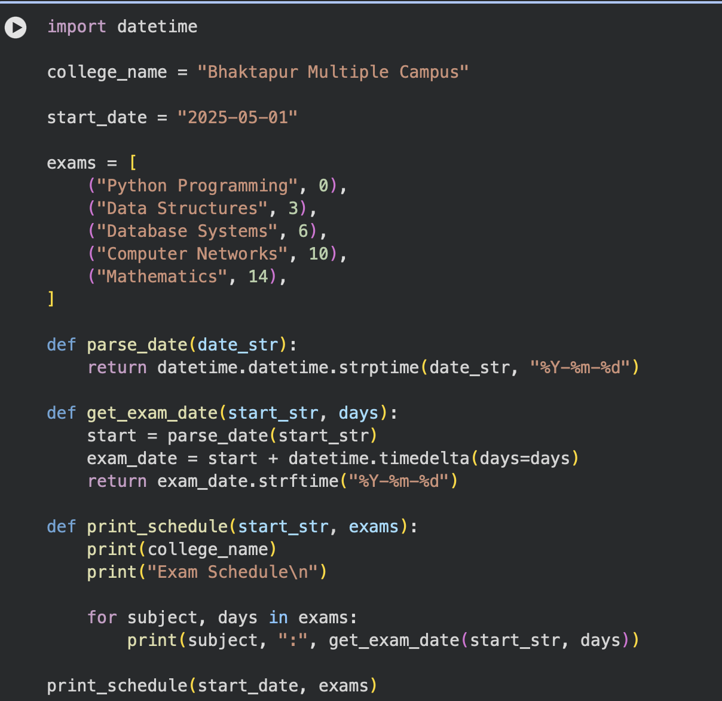
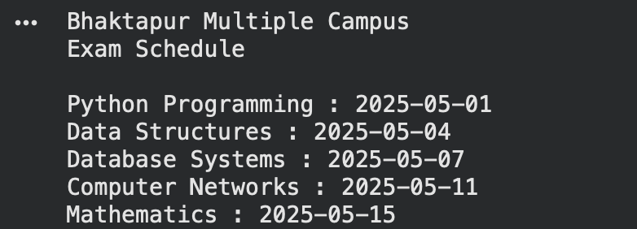

Question 4: Discount for Shopping
In this program, we use an example of how to develop and implement our own module called discount.py. This module includes methods that allow us to apply discounts and add VAT as well as compute the final price. In the main program, we import the final_price() function and the constant value TAX_RATE.
